CSA1717-ARTIFICIAL INTELLIGENCE
PRACTICAL LAB EXPERIMENTS
NIHARIKA PREEJESH (192524506)

PROGRAM 6: DEPTH FIRST SEARCH

Aim:
To implement the Depth First Search (DFS) algorithm to traverse all the nodes of a graph by exploring one branch completely before backtracking.
Algorithm
- Start from the source node.
- Mark the source node as visited.
- Visit the node.
- For each adjacent node:
  - If it is not visited:
    - Recursively perform DFS on that node.
- Continue until all nodes are visited.

Flowchart:
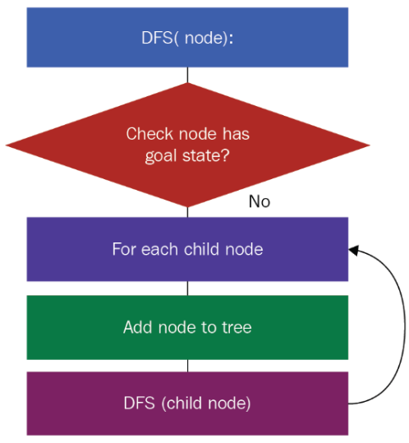
Output:
The graph is traversed by visiting nodes as deep as possible before backtracking.

Example Output:

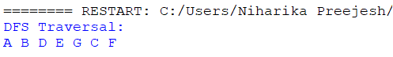

Result:
Thus, the Depth First Search (DFS) algorithm was implemented successfully, and all the nodes of the graph were traversed.

